**Group: Access-Ability Innovators**

**Team members:**

**El Shammas, Lama Rita**

**Li, Jiaying**

**Truong, Tam K**

**Srinivasan, Siddharth**

**Title: Concept Schema**

**1. In your interviews what are the top 5 concepts that are repeated?**

Testing, Problem Identification, Data Analysis, Design, assistive technology

**2. For each of these concepts, what are the attributes associated with those concepts?**

***Testing***: Type of tests

***Problem identification***: users’ disabilities, user research, database

***Data Analysis***: qualitative, quantitative

***Design***: Accessible Content, inclusive design, universal design, accessible design

***Assistive technology***: aids, visual tools, hearing aids, adaptive tools

**3. For each attribute, what is the list of qualitative (non-numerical) values they might take?**

***Problem Identification***

User’s disabilities: Dyslexia, blind, visually impaired, deaf

User Research: contextual inquiry, interviews

Incompatible Files: Picture

***Testing:*** *Type of testing*: A|B testing, usability test, functional testing, regression, end-to-end, performance

***Data Analysis:*** cleaning, visualization, interpretation, validation

***Design:*** UI, UX, aesthetics, usability,coherence, consistency, sustainability, adaptability, maintainability

***Accessible Content***: intuitive, effective, robust, keyboard accessibility, captioning, readability

***Assistive Technology***: wheelchairs, walkers, screen readers, CCTV, NVDA, OLX, JAWS, Braille readers, magnifiers, screen readers, braille devices, electronic glasses

***Screen reader***: JAWS, Narrator

***AssistiveTech Network***: Database, assessment, evaluation, research development, community building

**4. For each of the top 5 concepts, what are two closely related concepts? Add these to your schema.**

Assistive technology and Student

Screen reader technology, screen reader

Error handling, unsupported file

VisuallyImpaired, Student

**5. Create a UML diagram of the conceptual schema described in steps 1-4.**

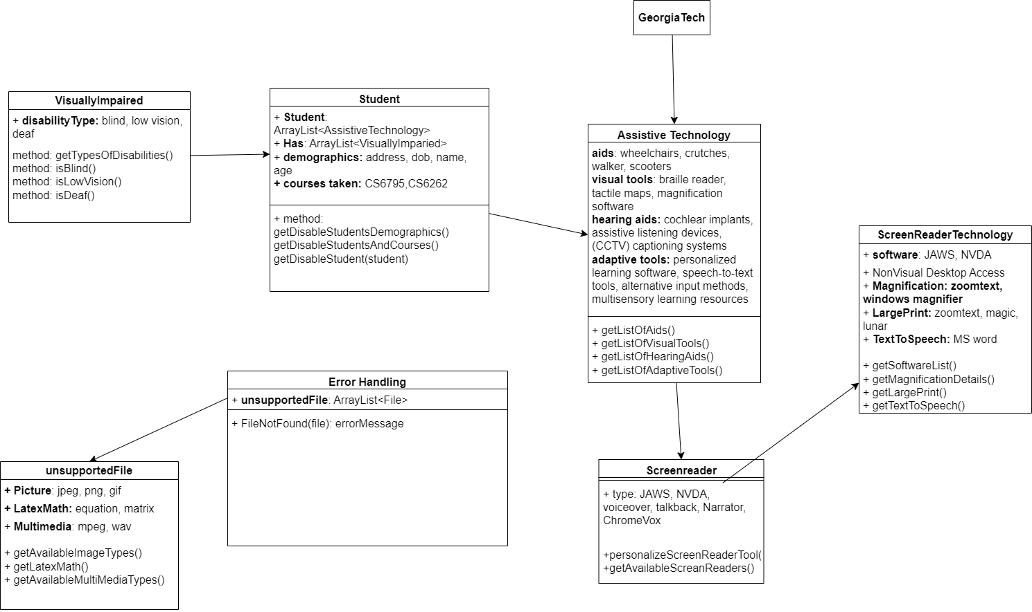

**6. How might you adjust your interviews to better determine the concepts, attributes, default values, and additional important concepts?**

We would want to adjust our interviews to focus more on the design process than what the designers find through their projects. We might have to get into details on various attributes the interviewees find helpful in their projects. The additional tools and experiences they have gone through in their specific tasks will help us with the attributes and detailed values needed for a better cognitive design.